LAB 2

1. pwd



1. echo $HOME



1. logname



4. ls -a

5. ls

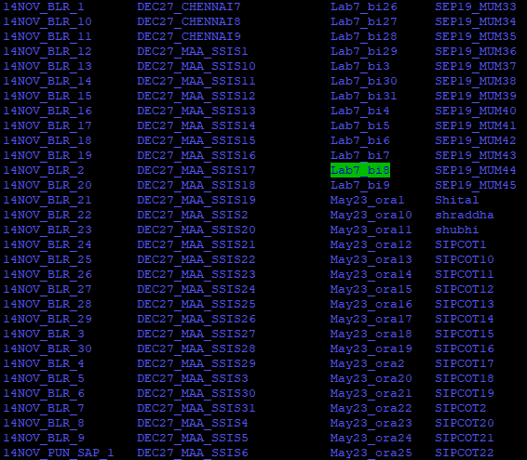

6. ls –l

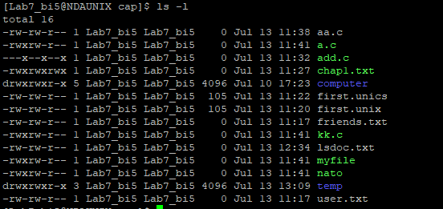

7. ls chap*

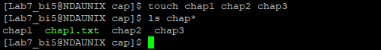

8. mkdir C_prog



9. mkdir newdir newdirectory 

10. ls -R 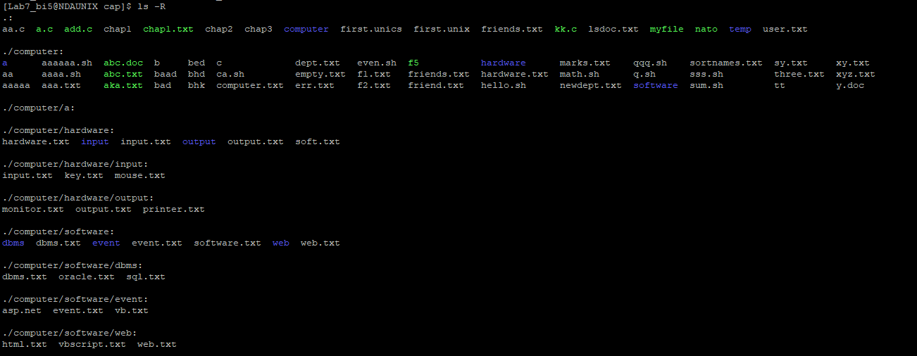

11. rmdir newdirectory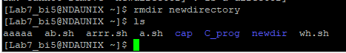

12. mkdir temp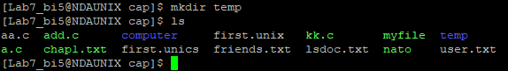

13. cd ..

rmdir newdir

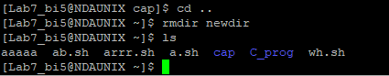

14. cd temp

mkdir directorynew

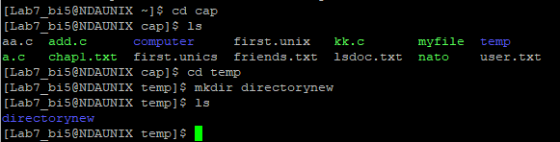

15. cd /home



16. cd /home/Lab7_bi5/cap/temp/directorynew

17. rmdir C_prog

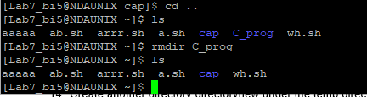

18. cd /etc

ls 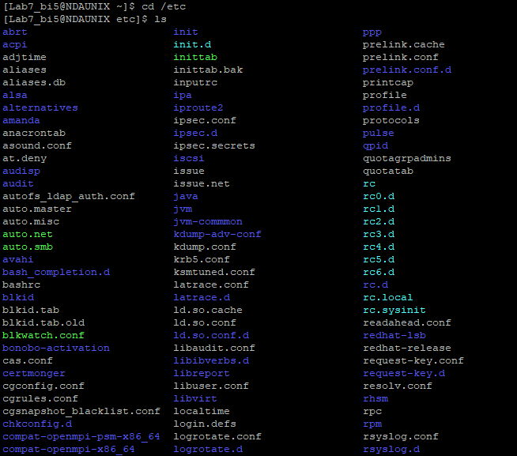

19. wc –l .*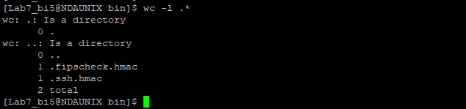

20. cat>first.unix

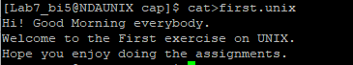

21. tee first.unics<first.unix 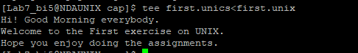



22. cat first.unix first.unics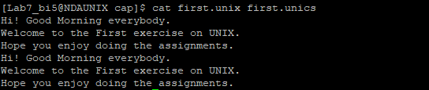

23. mkdir hey



24. cp * temp/ 

25. mv first.unix temp/second.unix 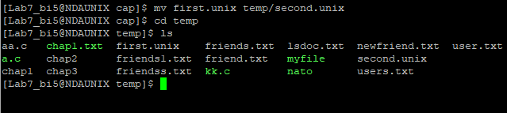

26. rm first.unics 

27. cd temp

rm *

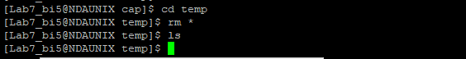

28.

29. cp *.unix temp/ 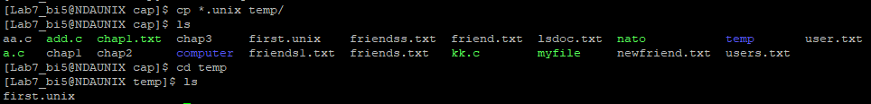

30. rm –R temp 

31. cp a b

mv a aaa

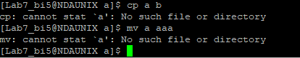

32. cat>friends.txt

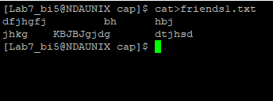

33. cat friends.txt

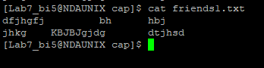

34. tee newfriend.txt<friends1.txt 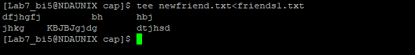

35. cat friends1.txt newfriend.txt 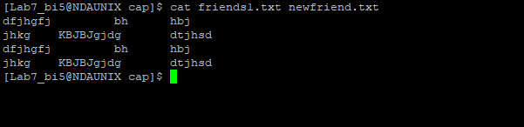

36. who>user.txt

cat user.txt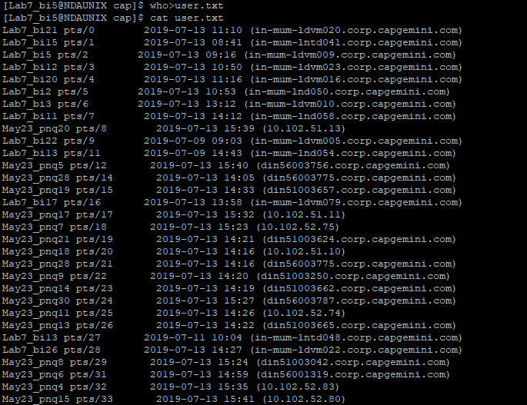

37. tee users.txt<friends1.txt

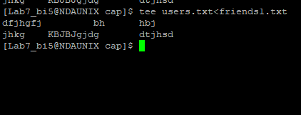

38. date



39. cal 08 1996

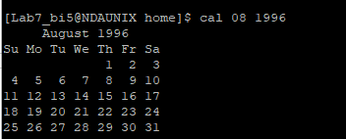

40. date “+ %”

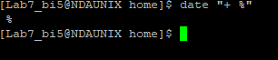

date “+%m”



date “+%D”



date “+%/%Training Activity”



date “+%Training Activity”



date “+%r”

